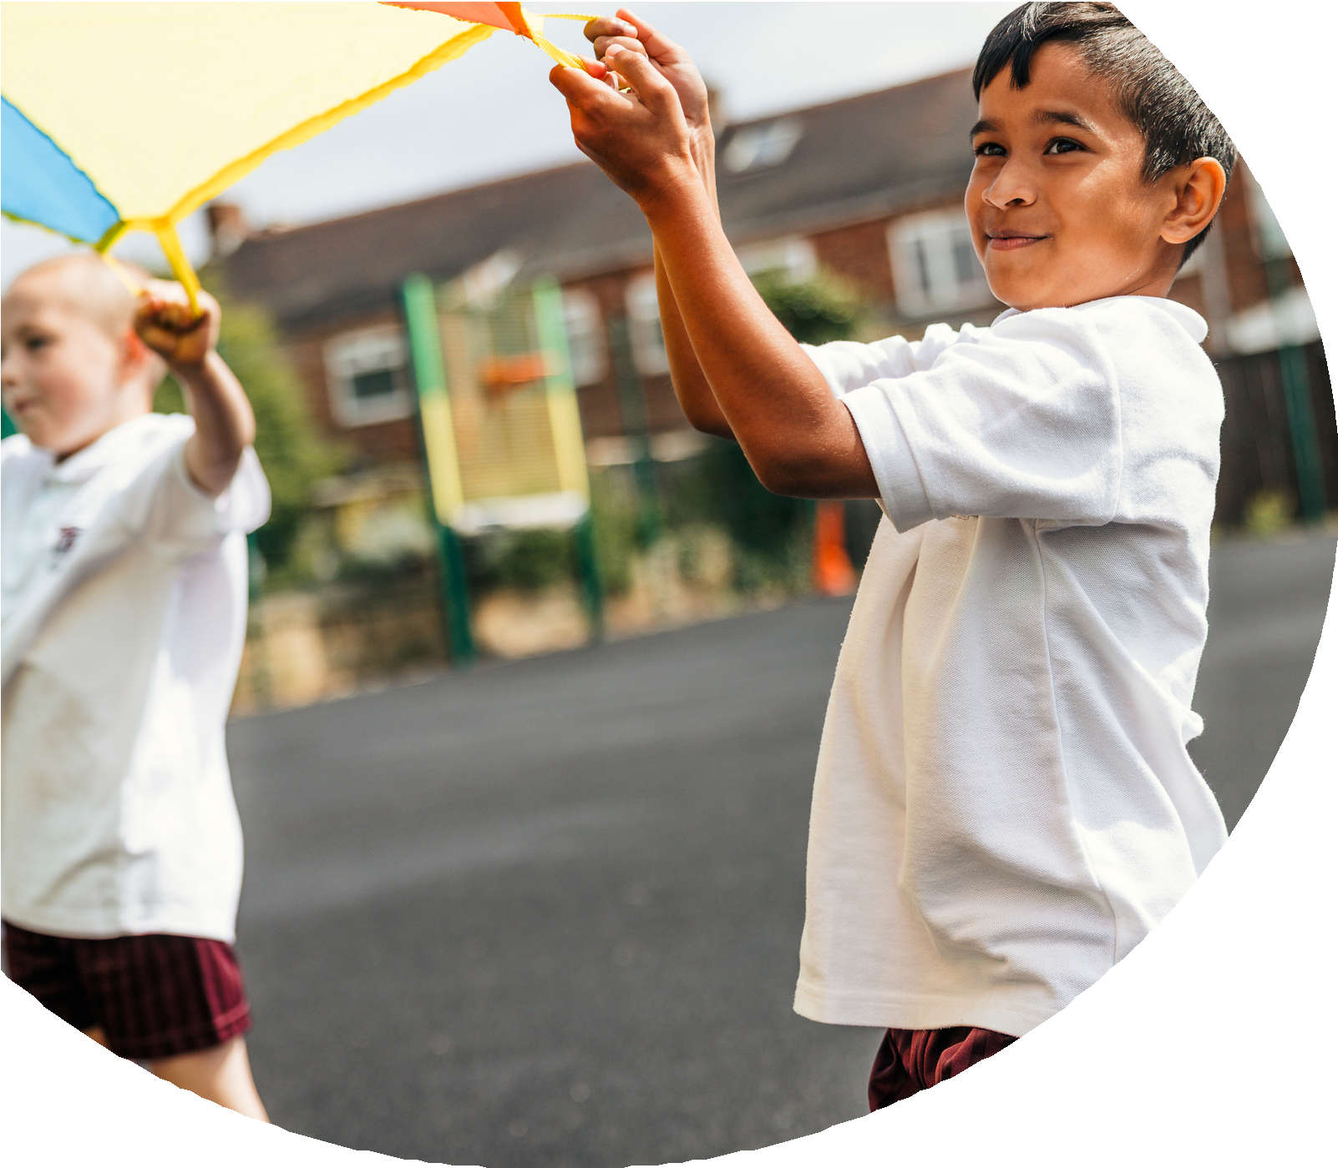
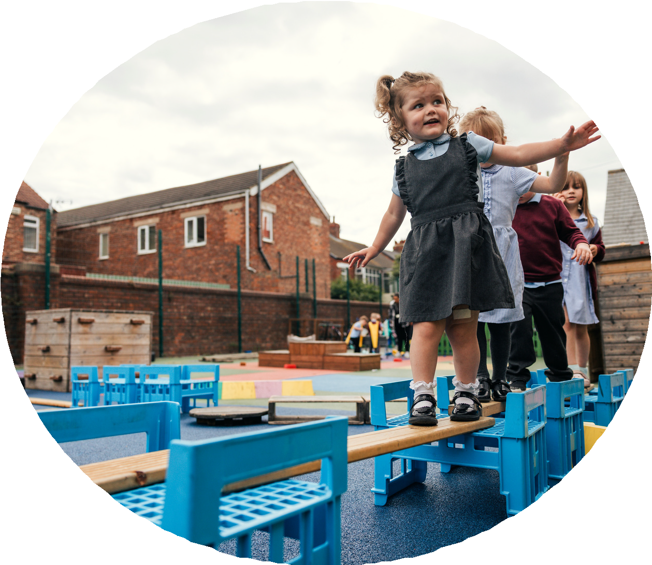

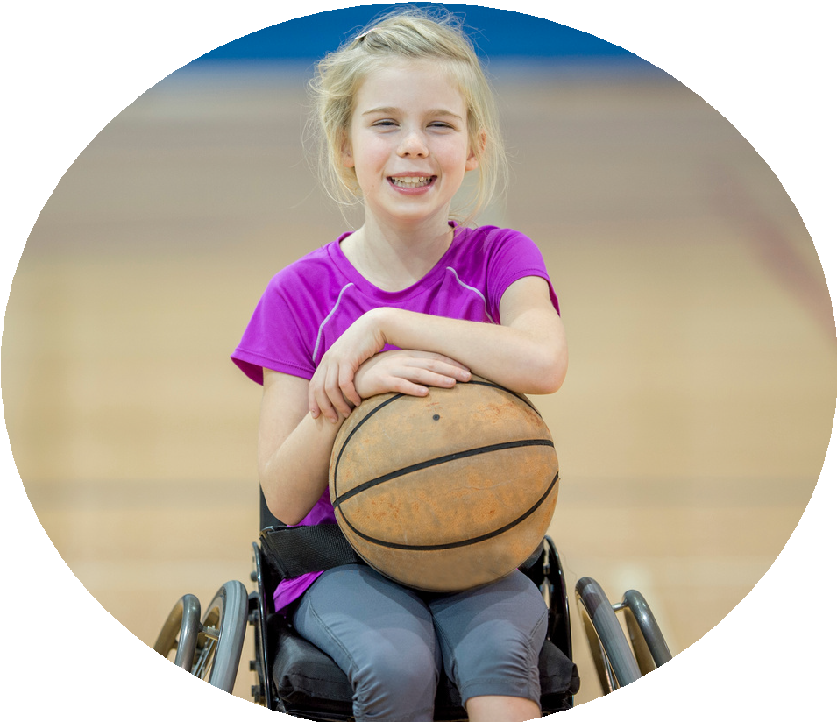



PE and sport premium monitoring and tracking form 2025/2026

Commissioned by

Created by

Review of the last academic year (2024/2025)
- Take some time to reflect on your intent, implementation and impact from last academic year to celebrate your wins but to also think about improvements for the year ahead.
- You do not need to complete every box. Just record the information that is key to your school's priorities and areas of focus.
Remember - Be clear about how you focussed spending on key groups such as SEND, girls and disadvantaged pupils.

Swimming and Water Safety | What went well? Supporting evidence? | What didn't go well? Supporting evidence?
1. Swim competently, confidently and proficiently over a distance of at least 25 metres | % at 49% | Small increase from previous year.  Elite swimming to be used for 4 weeks intensive swimming to raise standards.
2. Use a range of strokes effectively (for example, front crawl, backstroke and breaststroke) | N/A | Recording of length not stroke. NB Reporting tool to be revised to allow for this.
3. Perform safe self-rescue in different water-based situations | N/A | Not covered at Longsdale.

Key areas as outlined in PE and sport premium guidance | What went well? Supporting evidence? | What didn't go well? Supporting evidence?
1. Increasing confidence, knowledge and skills of all staff in teaching PE and sporting activities prioritising CPD and training where needed | Dance and AM Sport supported ECT staff and staff moving between year groups and phases.  All Year groups 1-6 provided training. | FS only Dance  Increase through work with DCCT
2. Increasing engagement of all pupils in regular physical activity and sporting activities | Clubs  - 16% of all clubs attended by PP children.  - 3 children with EHCPs  - All years groups year 1-6 had access to clubs every half term.  3 Clubs each half term | NO FS clubs
  Autumn | Spring | Summer
  Autumn 1  Year 1 and 2 – Multi-skills AM Sport  Year 3 and 4 - Cheerleading Corinna  Year 5 and 6 - Football Boys and Girls – RS Sport | Spring 1  Year 1 and 2 – Games AM Sport  Year 3 and 4 – Handball RS Sport  Year 5 and 6 - Football Boys and Girls – RS Sport  Dance – Corinna | Summer 1  Year 1 and 2 – Gymnastics RS Sport  Year 3 and 4 - Games AM Sport  Year 5 and 6 - Football Boys and Girls – RS Sport  Dance – Corinna
  Autumn 2  Year 1 and 2 – Dance Corinna  Year 3 and 4 - Multi-skills AM Sport  Year 5 and 6 - Football Boys and Girls – RS Sport | Spring 2  Year 1 and 2 – Multi-sports AM Sport  Year 3 and 4 – Handball RS Sport  Year 5 and 6 - Football Boys and Girls – RS Sport  Dance – Corinna | Summer 2  Year 1 and 2 – Athletics AM Sport  Year 3 and 4 - Gymnastics RS Sport  Year 5 and 6 - Football Boys and Girls – RS Sport  Dance – Corinna
3. Raising the profile of PE and sport across the school, to support whole school improvement | High profile mini leaders and on dojo from enrichment events.  - Every day – dance club  - Wednesday/Thursday KS2 – Mini leaders  - Thursday KS1 – Mini leaders  - Lunchtime supervisors / Mini leaders, coaches - as they need to lead the activity pupils – as they will take part.  All Year groups Enrich event  Year 4 – Mega Fest  Year 6 – Dodgeball  Year 2 – Athletics  Year 5 Cricket  Year 1 – Fundamentals  Year 3 – Tennis  FS – Santa wake and shake  FS and Year 1 Archery – Super schools  Celebration of Dance  Girls football Big event  Competitions – Football EFL league, Handball RS Sports RS sports inclusive football, RS Sports competitive football league.  Virtual competitions DCCT – Halloween event – all kS1, Sports Hall event – all KS1  KS1 Wimbledon – all KS1
4. Offer a broader and more equal experience of a range of sports and physical activities to all pupils and ensure equal access to sport for boys and girls | See Above Clubs and profile.
5. Increasing participation in competitive sport | Competitions – Football EFL league, Handball RS Sports RS sports inclusive football, RS Sports competitive football league.  Virtual competitions DCCT – Halloween event – all kS1, Sports Hall event – all KS1  KS1 Wimbledon – all KS1 | Increasing to 10 RS sport events this year.


Aims for the next academic year (2025/2026)
- Using your whole school priorities, school development plan and previous PE, school sport and physical activity data, set out your aims for the year ahead.
- Think about specific areas of need such as inactive girls, SEND and disadvantaged pupils
- Remember to also input your swimming data and reflections in the table located at the bottom of this page.
- Consider which of the 5 key areas improvements will be focussing on:
- Increasing confidence, knowledge and skills of all staff in teaching PE and sporting activities prioritising CPD and training where needed.
- Increasing engagement of all pupils in regular physical activity and sporting activities
- Raising the profile of PE and sport across the school, to support whole school improvement
- Offer a broader and more equal experience of a range of sports and physical activities to all pupils and ensure equal access to sport for boys and girls
- Increasing participation in competitive sport
Swimming and Water Safety | Input data | Reflections
1. Swim competently, confidently and proficiently over a distance  of at least 25 metres | 74% of year 6 pupils can swim 25m  NB – Elite swimming figures show positive response | Using elite swimming for Year 4 pupils. NB Data may not show improvement until 2027/2028.
2. Use a range of strokes effectively  (for example, front crawl, backstroke and breaststroke) | 74% of year 6 pupils have a range of strokes | Using elite swimming for Year 4 pupils. NB Data may not show improvement until 2027/2028.
3. Perform safe self-rescue in different water-based situations | 0% No data for this until 2026/27 year 6 leavers. | Using elite swimming for Year 4 pupils. NB Data may not show improvement until 2027/2028.

Aims for the next academic year (2025/2026)
Aim | Why? | Key area | Supporting evidence
To achieve Silver in the school games Mark. | To promote physical activity in the school. To ensure all children have a say in their PE Curriculum. | Increasing engagement of all pupils in regular physical activity and sporting activities.  Raising the profile of PE and sport across the school, to support whole school improvement. | School games mark Silver awarded 15/07/26
To develop leader and staff confidence with the new PE curriculum. Including the developing of adapative teaching in PE and the introduction of physical literacy in the PE curriculum. | To ensure all staff have a firm understanding of what physical literacy means and how to promote this in school. | Increasing confidence, knowledge and skills of all staff in teaching PE and sporting activities prioritising CPD and training where needed. | SW and TD attended training which included adaptive teaching 20/010/25  09/12/26 – In school Training for SW, TD, JC, SM, RA and CO on how to deliver the PL programme  Staff Meeting on Adpative teaching and physical literacy (Think, Feel, Move, Connect) 04/02/26  JS of DCCT did twilight training for all teachers and HLTAs on 17/03/26.
To develop a broader variety of clubs to encourage more engagement with KS2.(girls/SEND) | To improve participation in clubs by girls and SEND pupils in KS2. | Offer a broader and more equal experience of a range of sports and physical activities to all pupils and ensure equal access to sport for boys and girls.  Increasing participation in competitive sport. | Other clubs – Dance, Gymnastics, Boccia, invasion games, dodgeball, handball, athletics, football, netball and cheerleading Introduced Girls football club for year 5/6  Clubs have been linked to competitions
To develop pupil voice in PE to engage children more in the PE curriculum and develop their physical literacy. | To promote physical activity in the school. To ensure all children have a say in their PE Curriculum. | Increasing engagement of all pupils in regular physical activity and sporting activities. | Mini Leader voice/pupil voice held  PE and extra curricular held
To introduce Think, feel, move, connect into the PE curriculum. | To ensure all staff feel confident to implement the new physical literacy strand into their PE curriculum. | Increasing confidence, knowledge and skills of all staff in teaching PE and sporting activities prioritising CPD and training where needed. | Staff Meeting on Adpative teaching and physical literacy (Think, Feel, Move, Connect) 04/02/26  Ongoing in September
To develop physical literacy to support writing. | To develop children’s core muscles and produced more resilient writers. | Increasing engagement of all pupils in regular physical activity and sporting activities. | 67% of children have successfully completed the Physcial literacy scheme.
To develop clubs/ engagement activities for FS and the Orchard. | To ensure all staff feel confident to implement PE within children of all ages. | Increasing confidence, knowledge and skills of all staff in teaching PE and sporting activities prioritising CPD and training where needed.  Increasing engagement of all pupils in regular physical activity and sporting activities. | Derby County Community Trust – Fundamentals through play programme in Summer1/2 (FS)
To increase the number of children swimming 25 metres. (Year 4) | To ensure more children are able to swim 25 metres. | Increasing engagement of all pupils in regular physical activity and sporting activities.
To take part in 10 RS sports competitions this year. | To ensure more children have access to competetive sport. | Increasing participation in competitive sport.

Plan, monitor and evaluate (2025/2026)
- Please aim to use this as a live working document through the year.

- Keep returning to this to evidence adaptations and progress made through the PESSPA opportunities you provide.

- There is no set number of objectives you must have.

- Make as many or as few as you see fit that will support your aims for the year ahead.

- Consider which of the 5 key areas improvements will be focussing on:
- Increasing confidence, knowledge and skills of all staff in teaching PE and sporting activities prioritising CPD and training where needed.
- Increasing engagement of all pupils in regular physical activity and sporting activities
- Raising the profile of PE and sport across the school, to support whole school improvement
- Offer a broader and more equal experience of a range of sports and physical activities to all pupils and ensure equal access to sport for boys and girls
- Increasing participation in competitive sport

n, monitor and evaluate (2025/2026)

Example objective shown below is for reference purposes only:
 | Intent – what is your objective? | Implementation - How will you achieve this? | Impact - What do you hope to see? | Supporting evidence
Plan and monitor | Develop lunchtime play provision to increase activity for least active groups. | Develop pupil leadership (training programme), Midday supervisor training, Staff CDP to develop their understanding of games and play, Range of equipment, Youth voice activities to understand pupils wants and needs Outdoor play provision such as OPAL | A confident and competent group of activity leaders that take initiative and create a more active and inclusive playground for all pupils. Midday supervisors and all staff leading a range of physical activities and joining in with movement daily to role model. A happier, more active playground that meets the needs of all pupils especially SEND and girls. | Youth voice data through half-termly surveys and interviews/group discussions with a variety of pupils (leaders, children participating and those that are less active at break times). Conduct regular observations of the playground to gauge activity levels of the least active children. Staff voice and feedback
 | What impact have you seen? | Are the improvements sustainable? How? | Supporting evidence | Approx. cost
Evaluate | Activity leaders are leading a broad range of activities and actively seeking children that are not engaged in physical activity during lunch times. Midday supervisors have grown in confidence and far more active and engaged in games with the children. Lunch times are more active with children having fun. Activity options have been tailored to suit the needs of SEND pupils through considerate choices of equipment and the types of games played. Girls are proving to be the hardest group to engage as some are still choosing not to be active | Continued training for activity leaders and bringing new leaders into the group to bring new ideas and expertise. More leaders will also mean more activities are able to be delivered. Continued training with midday supervisors. Establish lead midday supervisors to empower them and give them ownership. Continue to listen to SEND pupils and tailor activities to their needs and wants. Focus priorities on engaging girls. Work with least active girls to create activities that are meaningful and enjoyable for them. Do they want to be activity leaders for younger children to give them purpose and confidence? | 100 out of 100 activity leaders want to carry on with this role next year. 30 more children have enquired to joining the team. Meetings and the end of year survey have shown all leaders feel positive and enjoy making a difference for others. Interviews by random selection were conducted and 92% of pupils were either 'happy' or 'very happy' with the activities on offer at lunch time. End of year physical activity survey findings such as:  - Am I involved with games at lunch time - 89% Yes  - Do I enjoy lunch time? 97% Yes  - Have I joined in with a game with the activity leaders? 100% Yes | Physical Resources - £1000  CPD for staff - £500  OPAL - £8000
Your Objective: To achieve Silver in the school games mark.

S

 | Intent – what is your objective? | Implementation - How will you achieve this? | Impact - What do you hope to see? | Supporting evidence
Plan and monitor | To achieve Silver in the school games Mark.  To develop pupil voice in PE to engage children more in the PE curriculum and develop their physical literacy. | - Mini leaders to be involved in pupil voice about the clubs and lunch time provision provided.  - More intra-school competition in Key Stage 2 . (Termly Games)  - Continue KS1 intra-school and inter school virtual competitions.  - PE leads to receive training on physical literacy (Oct 20th)  - All staff to receive training on physical literacy and its impact on the PE curriculum.  - To have a clear aim for all competitions in school.  - To increase the variety of sports on offer in school. | Confident mini leaders with an ownership of the lunchtime provision.  More competitions engaging a larger variety of children in school.  Staff confident to speak about physical literacy and its impacts on the PE curriculum. | Pupil Voice  Monitoring of engagement.  More children engaging in clubs.  Staff voice
 | What impact have you seen? | Are the improvements sustainable? How? | Supporting evidence | Approx. cost
Evaluate | Silver Mark achieved  Mini leaders involved in pupil voice and active in changes in PE curriculum.  Confident mini leaders. Leading intra school activities and leading parent events.  More intra school competition undertaken.  All staff trained on Physical literacy and adaptive teaching – Jack Southwart DCCT and staff meeting time. | Yes  Mini leader pupil voice to be planned into 2026/2027 timetable.  Intra school competition termly | Min leader pupil voice  Intra school competition records.  Staff Meeting slides and DCCT trust slides. | £500.00 DCCT staff meeting  Mini leaders programme £250.00

Your Objective: To develop staff confidence with the new PE curriculum.

 | Intent – what is your objective? | Implementation - How will you achieve this? | Impact - What do you hope to see? | Supporting evidence
Plan and monitor | To develop leader and staff confidence with the new PE curriculum. Including the developing of adapative teaching in PE and the introduction of physical literacy in the PE curriculum.  To introduce Think, feel, move, connect into the PE curriculum. | SW and TD to attend PE conference on October 20th.  SW and TD to lead a staff meeting on physical literacy and its impact on PE.  SW and TD to lead a staff meeting on Think, move, feel, connect.  DCCT to lead twilights into adaptive teaching of PE.  TD/SW to monitor the implementation of Think, move, feel, connect.  TD/SW to undertake pupil voice on physical literacy and think, move, feel, connect. | Staff confident to speak about physical literacy.  Staff implementing Think, move, feel connect in PE lessons.  Staff feel more confident to adapt teaching of PE to meet the needs of all children in their class. | Staff voice  Monitoring evidence
 | What impact have you seen? | Are the improvements sustainable? How? | Supporting evidence | Approx. cost
Evaluate | All staff introduce to physical literacy through staff meeting – Jan 2026.  All staff introduced to move, think, feel connect. | N/A | Staff meeting slides | N/A

Your Objective: To promote a broad variety of clubs and engagement in physical activity.
 | Intent – what is your objective? | Implementation - How will you achieve this? | Impact - What do you hope to see? | Supporting evidence
Plan and monitor | To develop a broader variety of clubs to encourage more engagement with KS2.(girls/SEND)  To develop clubs from FS and the Orchard.  To develop pupil voice in PE to engage children more in the PE curriculum and develop their physical literacy. | Mini leaders to undertake a pupil voice about clubs (Autumn Term)  SW and TD to analyze results.  SW and TD to look at clubs over after analysis.  SW and TD to work alongside Raj to implement new clubs.  SW and TD to organize competition with RS sport  TD/MK to introduce Boccia and superstars club in KS1/FS  DCCT to provide Fundamentals through play/Rammie’s little movers, Rammie’s little potters.  TD to liaise with DCCT about ways to support the orchard with PE.  Work alongside BK to introduce SEND in PE resources.  (if needed purchase SEND resources) | SW/TD have a firm understanding of the children’s preferences for clubs/PE activities.  More engagement in clubs from FS  More girls and SEND pupils in KS2 accessing clubs.  FS have access to more PE activities.  Orchard to have access to PE/Club activities. | Club registers  Pupil Voice  FS club registers  Orchard PE/physical activity curriculum developed.
 | What impact have you seen? | Are the improvements sustainable? How? | Supporting evidence | Approx. cost
Evaluate | FS Enrichment through DCCT  (Fundamentals through play.  Pupil voice undertaken for all children from FS2 – Year 6.  Analysis undertaken from pupil voice | Yes | Pupil Voice information and analysis.  Enrich recorded on dojo. | £1500 DCCT Fundamentals through play programme

Your Objective: To develop physical literacy (intervention)
 | Intent – what is your objective? | Implementation - How will you achieve this? | Impact - What do you hope to see? | Supporting evidence
Plan and monitor | To develop physical literacy to support writing. | Ben Asquith to provide training for SW/TD/SM (SM Physical literacy champion with support from TD/SW)  And 3 other TA’s (year3/4/5)  After the training staff will identify 6-8 pupils in their year group to be assessed by Ben  After assessment children to be grouped by ability/ not year group.  Physical literacy timetable to be developed by TD/SW.  TD/SW to monitor sessions throughout the spring/summer term.  Ben to reassess children – Summer term | Improvement in children’s physical literacy skills.  More confidence to write.  More core stability.  Staff confidence to implement the programme is high. | Training notes  Assessment notes  Staff voice  Monitoring
 | What impact have you seen? | Are the improvements sustainable? How? | Supporting evidence | Approx. cost
Evaluate | Physical literacy programme embedded in school.  SM/TD/RA/JC/SW/CO – trained on assessment and physical literacy – Autumn Term.  Assessment after 6 weeks embedded into physical literacy programme.  100% of pupils made progress. | Yes  Physical literacy to continue in 2026/2027  New children in year 2 identified Autumn term and assessed September 2027 | Physical literacy assessments  Physical literacy spreadsheet. | £500.00 training DCCT

Your Objective: To increase Enrichment opportunities for FS and the orchard.

 | Intent – what is your objective? | Implementation - How will you achieve this? | Impact - What do you hope to see? | Supporting evidence
Plan and monitor | To develop clubs/ engagement activities for FS and the Orchard. | DCCT to provide Fundamentals through play/Rammie’s little movers, Rammie’s little potters.  TD to liaise with DCCT about ways to support the orchard with PE.  Work alongside BK to introduce SEND in PE resources.  TD to enquiry with Panathlon society.  (if needed purchase SEND resources) | FS to have more access to clubs.  Orchard PE/physical activity scheme developed. | Club registers  Pupil Voice  FS club registers  Orchard PE/physical activity curriculum developed.
 | What impact have you seen? | Are the improvements sustainable? How? | Supporting evidence | Approx. cost
Evaluate | Enrichment for Nursery and reception DCCT – Fundamental through play.  Research undertaken into Enrichment for children with complex SEND. (all opportunities in local area start in KS2) | Yes  Activities learnt through DCCT Fundamentals in play CPD to be embedded into the FS curriculum. | N/A | £1500.00 DCCT Fundamentals through play.

