

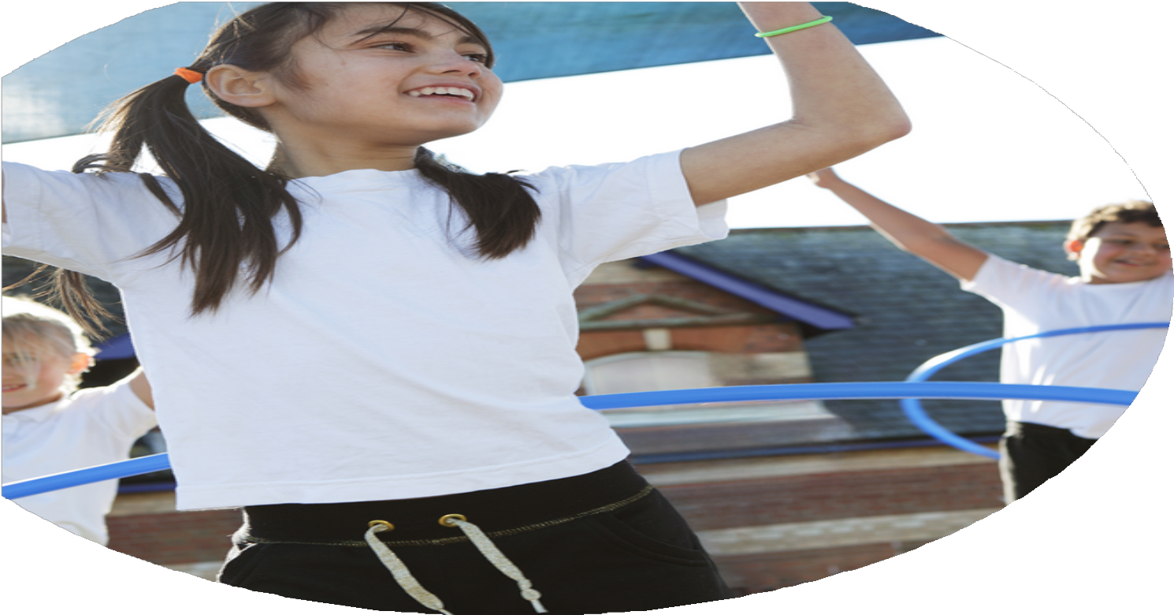





The Primary PE

and Sport Premium
Planning, reporting and evaluating website tool

Commissioned by

Created by

Images courtesy of Youth Sport Trust

PE Funding Evaluation Form

It is intended that this template should be used as preparation for the completion of the statutory digital reporting tool being introduced this academic year. You can upload data (including swimming) from this template onto this platform once it becomes accessible.
Before you decide how you are going to use the funding for this academic year you should reflect and evaluate the impact of your use of the funding in 2023/24.
All spending of the funding must conform with the terms outlined in the Conditions of Grant document. The template is a working document that you can amend/update during the year.
Based on your evaluation of last year’s funding you should decide what you intend to do this academic year, how you will do it, and what impact you expect it to have.

It is important that the funding is used effectively and based on your school’s needs.
You must use the funding to make additional and sustainable improvements to the PE and sport in your school. You must develop and add to the PESSPA activities that your school already offers.

Summative digital reporting from June 2025 will continue to include swimming and water safety information therefore funding can be used to provide top-up lessons where necessary to ensure pupils meet national curriculum swimming requirements

What are your plans for 2024/25 | How are you going to action and achieve these plans?
Intent | Implementation
Introduce lunchtime sport sessions/activities for pupils.  Key indicator 2 -The engagement of all pupils in regular physical activity – the Chief Medical Officer guidelines recommend that all children and young people aged 5 to 18 engage in at least 60 minutes of physical activity per day, of which 30 minutes should be in school.  Key indicator 4: Broader experience of a range of sports and activities offered to all pupils.  More pupils meeting their daily physical activity goal, more pupils encouraged to take part in PE and Sport Activities.  The impact of these activities has been good, children are engaged in physical activity for at least 30 minutes during the school day. | Raj has had dance every day at lunch times encouraging the children to take part in different styles and genres of dance while being active.  AM Sports to have multi-sports sessions every Tuesday with KS2 pupils  Success Criteria  - Every day – dance club  - Wednesday/Thursday KS2 – Mini leaders  - Thursday KS1 – Mini leaders  - Lunchtime supervisors / Mini leaders, coaches - as they need to lead the activity pupils – as they will take part.  Mini leaders – Virtual event and observation undertaken.  DCCT – Mini leader case study  ASDA money – outdoor equipment (£1000 ASDA Cash pot)  Mini leaders Festival  Cost - £250.00  AM Sports lunchtime provision/coaching  Cost - £3100
Develop active mile for all pupils through intra competition - Redwood Running (weekly event each term)  Key indicator 2 - The engagement of all pupils in regular physical activity – the Chief Medical Officer guidelines recommend that all children and young people aged 5 to 18 engage in at least 60 minutes of physical activity per day, of which 30 minutes should be in school.  Key indicator 5: Increased participation in competitive sport.  More pupils meeting their daily physical activity goal, more pupils encouraged to.  More children encouraged to compete. | Success Criteria  - Hall display  - Each class update  - Half termly competitions  Termly competitions to be introduced through assemblies.  House point dojos to be introduced – Spring Term.  Starting summer 1 or 2 – daily mile competition  Intra school competitions  KS1 Halloween event – October 2024  KS1 Sports Hall Athletics completion – April 2025  KS1 Wimbledon Tennis competition – June/july 2025  DCCT Core Affiliation - Cost - £1850.00
Training pupils to be mini sports leaders to increase physical activity levels and develop pupils’ leadership skills.  Key indicator 2  Key indicator 3.The profile of PE and sport is raised across the school as a tool for whole school improvement  The mini leader program has been successful this year in leading active play times and assemblies in keeping healthy and physically active the children have developed great leadership skills. | Success Criteria  - 15 children from Y 5 and 6  - DCCT training  - Half termly targets and meeting with DCCT coach.  Mini leaders, mini leader teacher (Raj), DCCT Coach, TD Support KS1  Initial training – Derby Tennis Centre  Mini leader resources purchased.  Year 6 mini leaders to train year 5 mini leaders.  Timetable set.  Mini leaders to choose games  Mini leaders introduced on dojo.  Mini leaders to be supported by TD/RA initial introduction.  TD/RA monitor  DCCT training and follow ups.  DCCT - mini leader package /Cost - £250.00  Training done and Mini leaders – Virtual event and observation undertaken.  DCCT – Mini leader case study.  Mini leaders resources purchased Cost £309.07  Mini leaders festival attended.
Purchase PE and playtime equipment.  Key indicator 2 -The engagement of all pupils in regular physical activity – the Chief Medical Officer guidelines recommend that all children and young people aged 5 to 18 engage in at least 60 minutes of physical activity per day, of which 30 minutes should be in school. | SW/TD audit of PE equipment  PE audit completed and resources purchased.  Pupil voice of what resources they would like on the playgrounds. (Completed by mini leaders)  Resources ordered  Audit undertaken and resources ordered and received.  Mini leaders equipment and T-shirts ordered.  Handball resources (introduction of a new sport)  Cost £1788.88
Provide extra-curricular clubs.  Key indicator 2 -The engagement of all pupils in regular physical activity – the Chief Medical Officer guidelines recommend that all children and young people aged 5 to 18 engage in at least 60 minutes of physical activity per day, of which 30 minutes should be in school.  Key indicator 5: Increased participation in competitive sport.  Key indicator 4: Broader experience of a range of sports and activities offered to all pupils. | Success Criteria  - Half termly send forms to sign up for different clubs  - Monitor on Get set 4 PE  - Offer a range of clubs  M Sport coaches  RS Sports Coaches  Corinna Dance Coach  3 Clubs each half term  Cost - £2097
  Autumn | Spring | Summer
  Autumn 1  Year 1 and 2 – Multi-skills AM Sport  Year 3 and 4 - Cheerleading Corinna  Year 5 and 6 - Football Boys and Girls – RS Sport | Spring 1  Year 1 and 2 – Games AM Sport  Year 3 and 4 – Handball RS Sport  Year 5 and 6 - Football Boys and Girls – RS Sport  Dance – Corinna | Summer 1  Year 1 and 2 – Gymnastics RS Sport  Year 3 and 4 - Games AM Sport  Year 5 and 6 - Football Boys and Girls – RS Sport  Dance – Corinna
  Autumn 2  Year 1 and 2 – Dance Corinna  Year 3 and 4 - Multi-skills AM Sport  Year 5 and 6 - Football Boys and Girls – RS Sport | Spring 2  Year 1 and 2 – Multi-sports AM Sport  Year 3 and 4 – Handball RS Sport  Year 5 and 6 - Football Boys and Girls – RS Sport  Dance – Corinna | Summer 2  Year 1 and 2 – Athletics AM Sport  Year 3 and 4 - Gymnastics RS Sport  Year 5 and 6 - Football Boys and Girls – RS Sport  Dance – Corinna
Promote cycling and walking to school.  Key indicator 2 -The engagement of all pupils in regular physical activity – the Chief Medical Officer guidelines recommend that all children and young people aged 5 to 18 engage in at least 60 minutes of physical activity per day, of which 30 minutes should be in school.  Key indicator 4: Broader experience of a range of sports and activities offered to all pupils. | Success Criteria  - Sign up to the ‘Big Pedal’.  - Deliver a Worship to promote the ‘Big Pedal’ and the benefits of walking, cycling and scooting to school. •  - Y5 pupils to complete ‘Bikeability’ level 2/3 award in cycling proficiency. • YR pupils to complete ‘balanceability.  Big PedaL Event 28th April – 2nd May  Bikeabilty undertaken – data recorded
Support teaching staff through access to ongoing training and mentoring with PE specialist to equip them with the knowledge, skills and confidence to teach High quality PE.  Key Indicator 1: Increased confidence, knowledge, and skills of all staff in teaching PE and sport.  AM Sport coaches  Corrina  Teaching staff  pupils – as they will take part. | Success Criteria  - Provide mentoring support for staff by providing specialist PE teachers (AM, CL,  - Identify staff with low confidence in teaching different areas of PE.  - Staff to observe HQPE lessons; team teach; plan and deliver lessons.  All year groups timetabled for AM Sport and Corinna  £5976
Book a range of competitions and Festivals for children from FS, KS1 and KS2 to take part in throughout the year  Teachers, Coaches, Admin staff  Pupils – as they will take part.  Key indicator 2 -The engagement of all pupils in regular physical activity – the Chief Medical Officer guidelines recommend that all children and young people aged 5 to 18 engage in at least 60 minutes of physical activity per day, of which 30 minutes should be in school.  Key indicator 5: Increased participation in competitive sport.  Key indicator 4: Broader experience of a range of sports and activities offered to all pupils. | Success Criteria  - Book events from the DCCT events calendar for all ages.  - Arrange transport and cover.  - Organise training sessions and clubs  - Attend events.  - Celebrate participation.  All Year groups Enrich event  Year 4 – Mega Fest  Year 6 – Dodgeball  Year 2 – Athletics  Year 5 Cricket  Year 1 – Fundamentals  Year 3 – Tennis  FS – Santa wake and shake  FS and Year 1 Archery – Super schools  Celebration of Dance  Girls football Big event  Competitions – Football EFL league, Handball RS Sports RS sports inclusive football, RS Sports competitive football league.  Virtual competitions DCCT – Halloween event – all kS1, Sports Hall event – all KS1  KS1 Wimbledon – all KS1  Cost - £2750
Increase participation of girls in sport  Key indicator 2 -The engagement of all pupils in regular physical activity – the Chief Medical Officer guidelines recommend that all children and young people aged 5 to 18 engage in at least 60 minutes of physical activity per day, of which 30 minutes should be in school.  Key indicator 5: Increased participation in competitive sport.  Key indicator 4: Broader experience of a range of sports and activities offered to all pupils. | Success Criteria  - Encourage girls to attend clubs  - Y5/6 Football training  - Arrange transport.  - Attend event.  - Celebrate participation.  Teachers, Coaches, Admin staff  pupils – as they will take part.  Girls Big Football Event 7th March  Girls Football club  Invite other schools to play friendly games of football after school.  Cost £100
Ensure SEND children attend clubs/festivals  Key indicator 2 -The engagement of all pupils in regular physical activity – the Chief Medical Officer guidelines recommend that all children and young people aged 5 to 18 engage in at least 60 minutes of physical activity per day, of which 30 minutes should be in school.  Key indicator 5: Increased participation in competitive sport.  Key indicator 4: Broader experience of a range of sports and activities offered to all pupils. | Success Criteria  - Ensure SEND children attend at least one festival or competition.  - Intervention for swimming.  Clubs – 44 Children on the SEND register have attended after school clubs this year with 2 children on a EHCP.  16% of club attendance was by SEND Pupils this year.  Cost - £2097
Non-swimmers in Year 5 to be provided with extra swimming lessons to achieve 25 meters and safe self-rescue, thus meeting the statutory requirements of the national curriculum for PE.  Other indicators identified by school | Success Criteria  - Identify swimmers after they have finished lessons in Year 4 who are unable to swim 25 meters.  - Provide additional lessons.  CD, swimming teachers.  Identified pupils  Additional Swimming for year 5 RC  Swimming for year 3/4 weekly.  Children identified by Year 4 teachers and CD/SW  RC top up swimming - 38 Children  29 Achieved 25 meters - 76% of the children  Cost - £6053.50

Club registers
Dojo videos
Get Set 4 PE
O’track/Sonar monitoring

Impact
- Increased activity during playtime/dinnertime
- More access to after school clubs.
- More access to enrichment opportunities to increase children’s physical literacy.
- Peer on Peer mentoring
- More participation of SEND Pupils in after school clubs
What impact/intended impact/sustainability are you
expecting?
How will you know? What evidence do you have or
expect to have?

Club registers
Dojo videos
Get Set 4 PE
O’track/Sonar monitoring

Impact
- Increased activity during playtime/dinnertime
- More access to after school clubs.
- More access to enrichment opportunities to increase children’s physical literacy.
- Peer on Peer mentoring
- More participation of SEND Pupils in after school clubs
- Greater participation with mini leaders at lunchtime
- Development of staff confidence
What impact/sustainability have you seen?
What evidence do you have?

