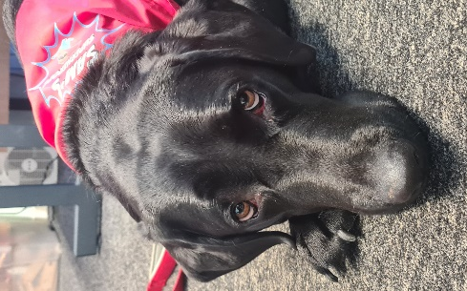

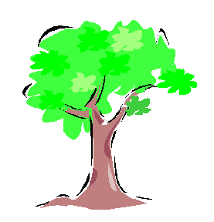

Redwood Primary School
Redwood Primary
School
in proud association with
Sam’s Superheroes

Daisy has been visiting Redwood Primary School on a weekly basis since 4th November 2021.
On the first session, I explained to Rachel about Pupil A. He often visits my office often when dysregulated and can be physically aggressive. I explained that he would probably not speak to her. As a child with SEND, a diagnosis of Autism and social, emotional and mental health needs, this particular child will speak to only 2/3 members of staff in school that he knows very well. Pupil A came into the room and Rachel introduced herself and Daisy. Pupil A sat down and began to stroke Daisy. Rachel asked him a simple question and he began talking! In those first 30 seconds, the impact was HUGE! I had to leave the room and have a little cry to myself! The child continued to talk and talk and talk. Since this date, he has not visited my office for anything other than to show me his great work! This is just a tiny snippet of magic that Daisy brings to Redwood.
Year 1 teacher: The children in my class brought their own books to share with Daisy today. When asked to tell Daisy how she made them feel I had responses such as “ She makes me happy", "She makes me calm", "She makes me smile" and "My heart loves her". The children look forward to her visits and I have seen an overall improvement in gentleness - not only towards Daisy but towards each other when playing too.
Year 2 pupils: Pupil B was almost in tears after Daisy left. I asked him why and he said ‘It’s the first time I have ever stroked a dog. It was so soft. I am so happy.’ Pupil C, who is one of our nurture children said ‘Wow I feel so calm.’ And Pupil D, a child who has English as an Additional Language told me in a whole sentence, ‘I like dogs, they go woof. They are soft.’
Year 2 teacher: The children all just love her - as do I! The language that comes from the children during and after her visit is wonderful - especially from EAL and SEND children. 'She's lovely, she's so soft, she's beautiful'. Just to see the smiles on some children's faces is precious – including those children who are sometimes withdrawn or lack emotion.
Year 2 teacher: From today's visit you can truly see the impact she has. As soon as she comes in, the children's faces light up and the whole class brightens. They were so kind and attentive and loved the session. The main impact I saw was on Pupil E. He was slightly nervous at first but grew slowly more confident. He carefully listened to instructions when told where he could pat her. At one point, it was as though it all got very emotional for him and he was just so happy and content that he hugged the lady that brought Daisy in (this is unusual for Pupil E to be so loving towards a stranger). Then he hugged Daisy and then hugged a child in the class. It was amazing to see him so happy. His language was really coming through and he was saying things like 'not pat Daisy on face, on head only' amongst other things, again he doesn't often speak so much. After the session, we asked Pupil E if he was happy or sad and he said 'Me happy, Daisy'. He kept asking about Daisy all afternoon.

